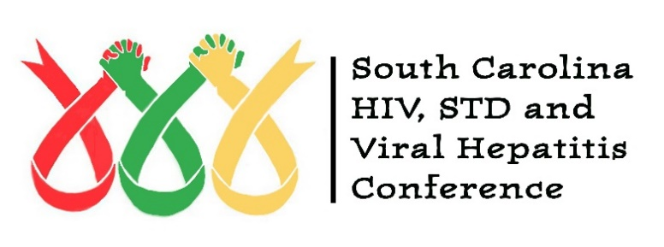

Dear Colleagues,

The SC HIV, STD & Viral Hepatitis Conference Planning Committee is pleased to offer a limited number of scholarship opportunities for persons living with HIV or AIDS (PLWHA) to attend the 2024 Conference at the Columbia Metropolitan Convention Center in Columbia, South Carolina, on October 23-24, 2024. The scholarship covers registration for the Conference, including continental breakfast and lunch. Unfortunately, transportation, hotel accommodations, and evening meals, are not included in the scholarship. However, we ask agencies to consider assistance with the above.

We welcome all eligible applications and ask that you assist us by sharing the attached information with PLWHA, case managers, peer counselors, and others who may find it beneficial. Please note the application may be accessed and/or completed online by visiting the conference website at www.schiv-stdconference.org.

The scholarships purpose is to assist persons living with HIV or AIDS who have the interest, availability, ability and commitment to provide support to HIV education, prevention, intervention, and/or care service efforts in their local communities. The committee’s priority is given to first time participants who would not be able to attend the Conference without assistance. The scholarship award is not for employees who work for any organization that provides service to PLWHA in any capacity.

A typed letter of recommendation from an ASO, doctor, case manager, or health care provider must be submitted with each application. The letter will be used to assist the review team with selecting the best applicants for a scholarship. The recommendation letter must clearly verify the author’s experience with the applicant’s interest and commitment to provide support to help with prevention and/or care services efforts in their local community. Observations noted by the applicant may be included. All letters must be on official provider/organizational letterhead and typed. Handwritten letters and letters not on letterhead will not be accepted.
The Scholarship Committee anticipates more applications will be received than can be funded; therefore, scholarships will be selected through a competitive process.

To apply for a PLWHA Scholarship:

1. All persons applying for this scholarship must be HIV positive.

2. Please have eligible applicants complete the application and submit all requested documentation.

3. All application packets including documents and letters be received by Friday, June 28, 2024 (NO EXCEPTIONS).

4. Applications and documents can be completed online via the conference’s website at www.schiv-stdconference.org or mailed to:

HIV, STD, and Viral Hepatitis Conference Scholarships
c/o AID Upstate
Attn: Inez Morris
P. O. Box 105
Greenville, SC 29602

5. All notifications of scholarship will be notified via email by Friday, August 2, 2024.

Thank you for your interest in the 2024 SC HIV, STD, & Viral Hepatitis Conference.

For additional information regarding the conference, and the application please see the conference website: www.schiv-stdconference.org.

If you have questions, or need help in submitting the application please contact Inez Morris (864) 787-2845 or by E-mail: inezmorris54@gmail.com

Sincerely,
Inez Morris, M.Ed.
Scholarship Workgroup Chair

